**Name:** Basant Raj Kadel  
**ID:** 80117739

**Lab:** 4

**Title:** Inter-Network Routing with Cisco Packet Tracer

**1. Objective**  
To demonstrate a router's role as a Layer 3 device in enabling communication between two separate networks (192.168.0.0 and 192.168.1.0).

**2. Theory**

* **Layer 2 Switches:** Handle communication within the same network using MAC addresses. Cannot route between different IP subnets.
* **Layer 3 Routers:** Connect different networks. Make forwarding decisions based on IP addresses. Each interface belongs to a different network and acts as the default gateway for devices on that network.

**3. Diagram & Procedures**

**Assuming that there are 4 computers which are connected via 2 switches. Now assigning IP addresses from Network 192.168.0.0 to PCs connected from SWITCH1 and 192.168.1.0 to PCs connected from SWITCH2.**

**Topology:**

* **Network 1 (192.168.0.0):** PC0, Laptop0 → Switch1 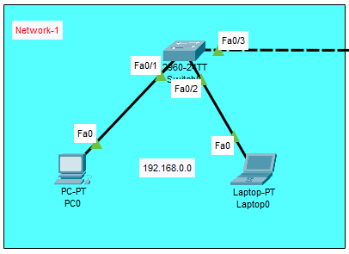
* **Network 2 (192.168.1.0):** PC1, Laptop1 → Switch2 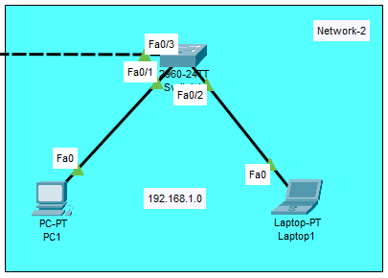

**Testing:**

* Pinging a PC of switch2 from PC of switch1 to see whether it receives the package or not.

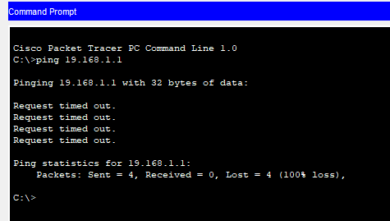

Here the packets are lost i.e. (the connectivity between the PCs are not established).

**To achieve internetwork communication, we require a Layer 3 device here. This can be achieved by using a Router in the above topology.**

**Topology:**

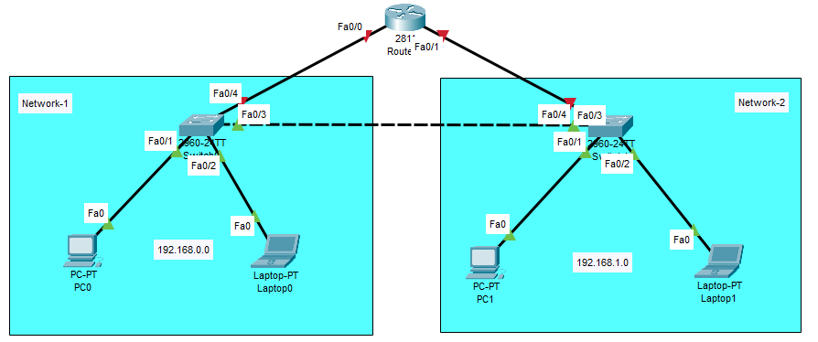

**Configurations:**

* Click on the router.
* Go to the CLI tab.
* Press Enter and type these commands:  
    
  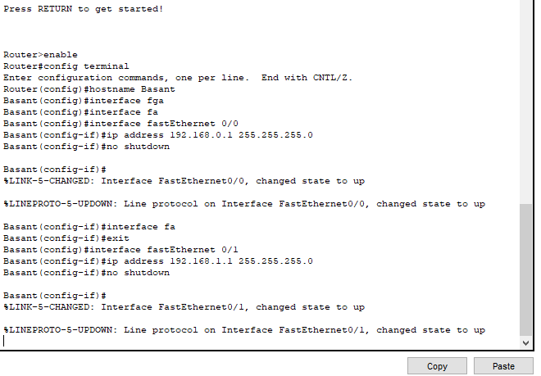

**4. Testing**

* Pinging 192.168.1.1 from PC0 to PC1 → **Success only after router configuration**.  
  **PC0 to Switch2:**   
  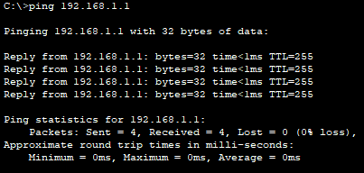

**PC0 to PC1:**  
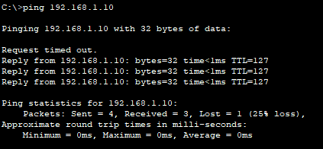

**5. Conclusion**  
The experiment confirmed that a Layer 2 switch cannot route between subnets. The router was essential to provide the path for inter-network communication. Successful pings between networks prove the router correctly forwarded packets based on IP addresses.